1. Create a simple Scrum Board for a 'Food Delivery App Testing' project using a spreadsheet or online tool (like Trello or Miro), with columns for Backlog, To Do, In Progress, and Done. Add at least 6 testing tasks such as 'Login Functionality Test', 'Order Placement Test', and 'Payment Gateway Test'.
Ans =
I created a simple Scrum Board spreadsheet for a Food Delivery App Testing project with the requested columns:
- Backlog
- To Do
- In Progress
- Done
It includes these testing tasks:
- Restaurant Search Test
- Profile Update Test
- Login Functionality Test
- Payment Gateway Test
- Order Placement Test
- Cart Functionality Test
- Logout Test

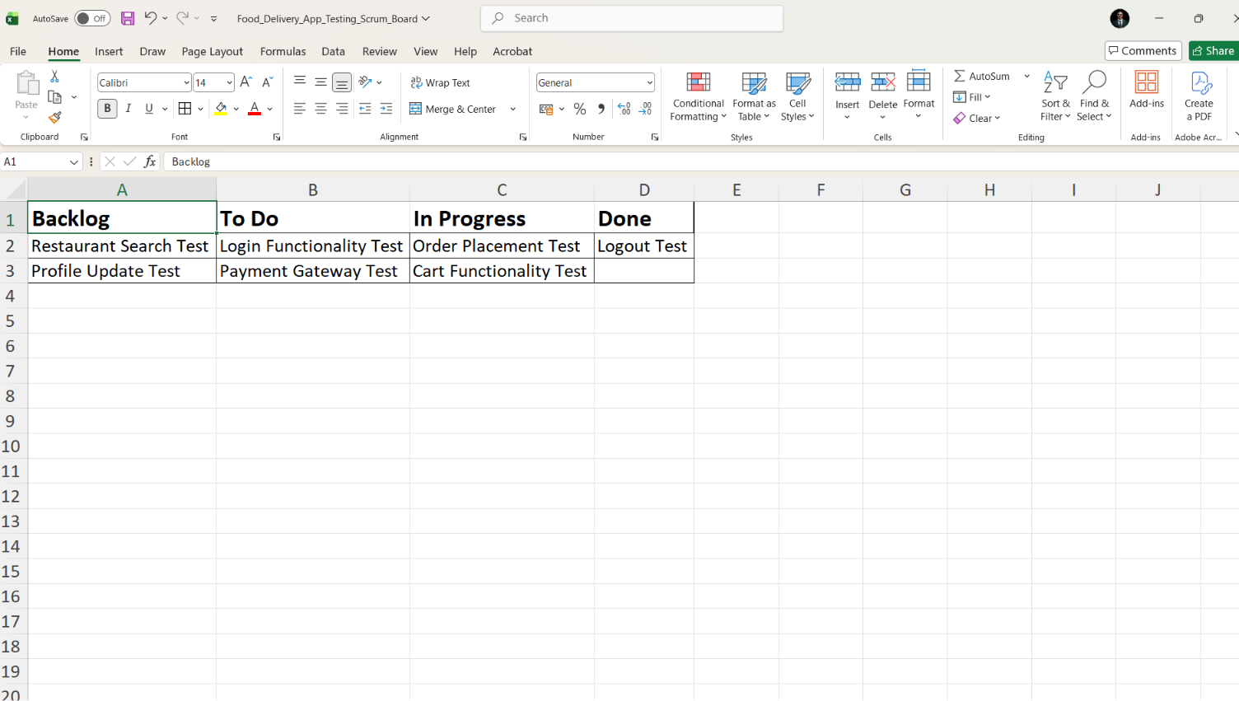

2. Write a short description of what happens during a Sprint Review in Agile, and explain how the testing team contributes to this meeting using an example from any app you use (such as Zomato or Instagram).
Ans =
Sprint Review in Agile
A Sprint Review is held at the end of each sprint to demonstrate the work completed by the development team. During this meeting, the team showcases new features to stakeholders, gathers feedback, discusses what was successfully completed, and identifies any changes or improvements needed for future sprints. The Product Owner reviews whether the sprint goals were achieved and updates the product backlog based on the feedback received.
Testing Team's Contribution (Example: Zomato)
In a Sprint Review for the Zomato app, the testing team presents the results of testing the new features, such as restaurant search, order placement, and payment processing. They report any bugs that were found and fixed, highlight any known issues or risks, and confirm that the tested features meet the acceptance criteria. For example, if a new "Live Order Tracking" feature was added, the testers would demonstrate that the tracking updates correctly, explain the test scenarios executed, and provide confidence that the feature is ready for release.
3. List 5 typical Agile testing activities that would happen during a 2-week sprint for a new feature in a popular app (for example, adding 'Dark Mode' to WhatsApp). For each activity, mention which Scrum Board column it would appear in at the start of the sprint.
Ans =
Testing Activity | Dark Mode Example | Column at Sprint Start
1. Test case/scenario design | Writing cases from acceptance criteria e.g., toggle behaviour, chat bubbles, status screen, media viewer rendering in dark mode | To Do
2. Test environment & data setup | Configuring test devices/OS versions (iOS/Android, various screen types) and accounts to test light↔dark switching | To Do
3. Exploratory/manual UI testing | Checking contrast, readability, icon visibility, emoji rendering, and third-party media previews under dark mode | To Do
4. Regression testing | Verifying existing features (wallpapers, chat themes, stickers, call screens) still work correctly once dark mode ships | To Do
5. UAT / Definition-of-Done review | Final sign-off against design specs and acceptance criteria before the story can move to Done | To Do
As the sprint progresses, you'd expect this movement:
- Day 1–2: Test case design and environment setup move to In Progress → Done
- Day 3–8: As dev finishes the toggle/UI work, exploratory testing moves To Do → In Progress → In Review
- Day 8–10: Regression testing follows the same path once core dark mode logic stabilizes
- Day 9–10: UAT is typically the last card to move, often gated behind all other testing cards reaching Done.

4. Pick any one feature from an app you use daily (like 'Add to Cart' in Flipkart or 'Stories' in Instagram) and break it down into at least 4 test tasks that would be tracked on a Scrum Board. Assign each task to a specific sprint day and explain your reasoning.<br><br><em><strong>Hint:</strong> Think about functional, UI, and integration testing for the feature.</em>.
Ans =
Feature Chosen: "Add to Cart” Flipkart Shopping App
I'll assume a 2-week Sprint (10 working days), tracked on a Scrum board with columns To Do-in progress-Testing- Done.
Test Task Breakdown
# | Test Task | Test Type | Sprint Day | Reasoning
1 | Verify tapping "Add to Cart" adds the correct product & default quantity | Functional | Day 1 | Core happy-path logic. Must be verified first every other test depends on this working.
2 | Verify quantity increments correctly when the same item is added repeatedly | Functional | Day 2 | Builds on Task 1; edge case of the same core flow, so tested right after the base case.
3 | Verify "Add to Cart" is disabled/hidden for out-of-stock or unavailable items | Functional | Day 3 | A boundary/negative case tested once the normal flow is confirmed stable, so any failure here is isolated.
4 | Verify button UI changes state (e.g., "Add to Cart" → "Go to Cart") after a successful add | UI | Day 4 | UI checks only make sense once functional logic is confirmed; testing UI before that risks re-testing after functional bugs are fixed.
5 | Verify cart icon badge count updates instantly and correctly | UI | Day 4 | Grouped with Task 4 since both are front-end state reflections of the same action efficient to test together.
6 | Verify UI responsiveness across screen sizes (phone/tablet) and orientations | UI | Day 5 | Broader UI/visual regression check scheduled after core UI states are validated, closer to mid-sprint when UI is more stable.
7 | Verify cart syncs correctly across devices when logged into the same account | Integration | Day 7 | Integration tests need functional + UI layers working first, plus backend sync placed after a short buffer (Day 6) for dev fixes.
8 | Verify price/discount/coupon updates reflect correctly in the cart total | Integration | Day 8 | Depends on pricing/inventory microservices a higher-complexity integration test scheduled later for more dev stabilization time.
9 | Verify real-time stock check integration (item goes out of stock while in cart) | Integration | Day 8 | Grouped with Task 8 since both hit backend inventory/pricing services in the same test session.
10 | Full regression + sign-off of "Add to Cart" flow | Regression | Day 10 | Final safety net before sprint review/demo confirms nothing broke from late-sprint fixes.

